Student Name: Calvin Moylan

Student ID: 30018702

Date: 14/08/2020

Assessment Title: Portfolio One

## AT 2: Activity 1

## Design Specifications

The application that needs to be completed is one that will use a nested class which is stored inside a doubly linked list. The purpose of this application is to store a class called “Country” which houses a class called “City” in a doubly linked list.

## Design Specifications Analysis

For this task, I have followed all requirements for the task, which includes having a nested class and a storing the class inside a doubly linked list.

I went about producing the application by first making the host class which would then include the inner class. I then create a doubly linked list which will store a list of the “City” class. The application then adds Cities to the Country class which is then put into the doubly linked list and then printed to the console.

I went about going this way as I believe it is the most efficient way to do something like this and it meets the question requirements.

UML  
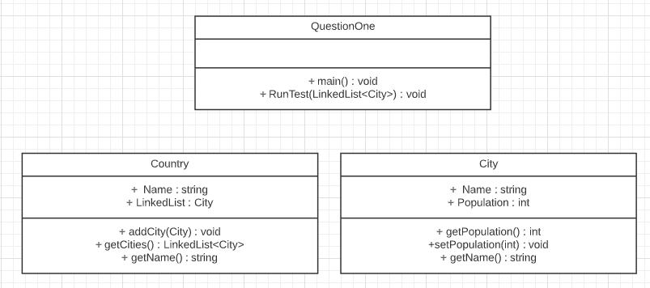

## Debugging

Adding a City  
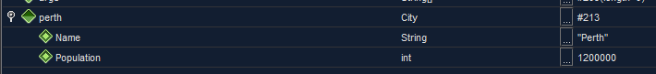

Creating a Country

Adding City to country  
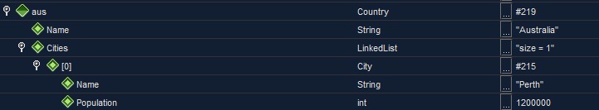

## Testing the Application

### Junit Testing

Testing to see if there are 4 items in Doubly Linked List:   
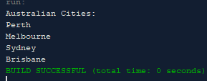  
Running expecting 5:  
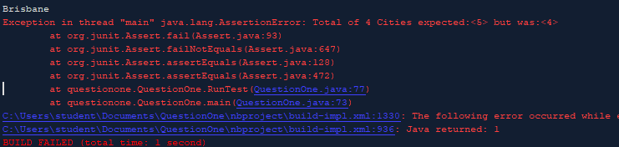

### Test and validate with sample inputs with screenshots.

|  |  |  |  |  |
| --- | --- | --- | --- | --- |
| **#** | **Test Case** | **Data** | **Expected Result** | **Actual Result / Comment** |
| *Case 1* | *Printing out all 4 cities* | *1 Country class, 1 linked list, 4 City class* | *Application prints out all 4 cities* | *Results as expected.*  *Ref Figure 1.1* |
| *Case 2* | *Printing out all 4 cities name and population* | *1 Country class, 1 linked list, 4 City class* | *Application prints out all 4 cities and their population* | *Results as expected.*  *Ref Figure 1.2* |
| *Case 3* | *Adding City to linked list* | *1 Country class, 1 linked list, 1 City class* | *City is added to linked list* | *Results as expected.*  *Ref Figure 1.3* |

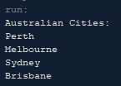

Figure 1.

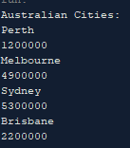

Figure 1.2

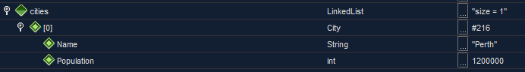

Figure 1.3

END OF TEST TABLE